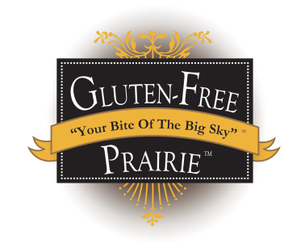
SIMPLY OUR BEST PANCAKES

Heat lightly oiled griddle on medium/low heat for about 10 min
Before you start! NOTE: The secret to this recipe is NOT to over mix it.

- 1 cup Gluten-Free Prairie Simply Wholesome All-Purpose Flour
- 2 tablespoons pure cane sugar (or sugar substitute)
- 2 teaspoons baking powder
- 1 teaspoon salt
- 1 teaspoon vanilla extract
- 1 cup milk (or milk substitute)
- 1 beaten egg
- 2 tablespoons vegetable or coconut oil
Blend GFP flour, sugar, baking powder and salt in a medium bowl.
In another bowl blend milk, egg and oil together
Make a well in the center of the dry ingredients and pour in wet ingredients
Using a whisk or wooden spoon, hand blend together just until smooth (do not use a mixer)
NOTE: Batter will be very thin
Pour about ¼ cup (or less for silver dollar pancakes) onto griddle. Adjusting heat as you go, brown each side– turning only once for best results.

Enjoy!

More recipes at: www.glutenfreeprairie.com

