Tropical Groat Salad
Serves: 4-6
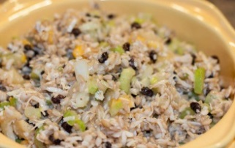

Ingredients:
- 2 C groats – cooked until dry and chilled (follow our recipe on the bag)
- ½ Can (10 oz) pineapple chunks in juice (*drained with juice reserved)
- 1 ¼ C shredded coconut
- ¼ C dried currants or raisins
- 1½ C celery (finely chopped)
- ½ Tsp celery seed
- 1 Fresh mango (diced ) (if necessary, substitute 1 can mandarin oranges – well drained)
- Salt to taste

Directions:
- Soak currants overnight (or as long as possible)
- Shred pineapple
- Mix together: groats, pineapple, coconut, mango, celery, celery seed and kosher salt
- Drain currants well, add and mix well
- Serve cold or just below room temp
More recipes: www.glutenfreeprairie.com

