OATMEAL CABBAGE SOUP

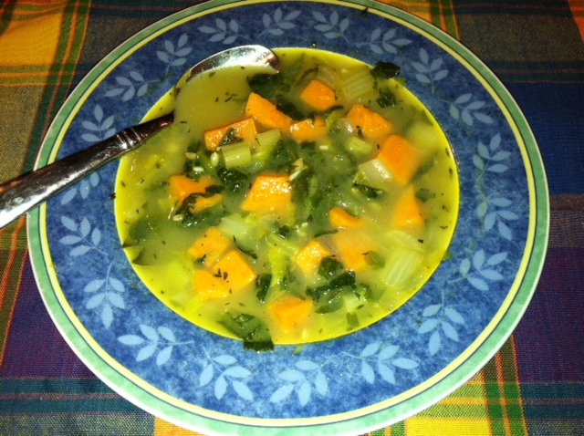
Makes 4 servings

Ingredients:
- 2/3 cup cooked Gluten-Free Prairie Oatmeal or Groats (see cooking directions on package)
- 1 tablespoon grape seed or olive oil
- 1 cup chopped onion
- 3/4 cup chopped celery
- 1 teaspoon minced garlic
- 4 cups chicken or vegetable stock
- 1 cup water
- 2 cups roughly diced sweet potato
- 2 cups chopped caggabe
- 2 bay leaves
- 1 tablespoon fresh thyme plus 1 teaspoon dried thyme
- 1 cup roughly diced roasted chicken (optional)
- Salt and freshly ground black pepper to taste

Directions:
- Heat a large saucepan on medium-low heat.
- Add the oil, onion, celery and garlic. Cook, covered, for about 7 minutes or until the vegetables are starting to soften, adding a tablespoon or two of water if needed.
- Pour in the stock, water, sweet potato, oat groats, cabbage, bay leaves, and thyme. Bring to a simmer and cook, covered, for 17 minutes or until sweet potato and groats are tender.
- Add the chicken and simmer until hot, 3 to 5 minutes.
- Add pepper and salt (if using) to taste.
- Serve

